# Section 4.3: Maxima and Minima

Finding the maximum and minimum values of a function has practical significance because we can use this method to solve optimization problems, such as maximizing profit, minimizing the amount of material used in manufacturing an aluminum can, or finding the maximum height a rocket can reach. This section looks at how to use derivatives to find the largest and smallest values for a function.

## Absolute Extrema

Let $f$ be a function defined over an interval $I$ and let $c∈I$.

We say $f$ has an **absolute maximum** at $c$ if $f(c)≥f(x)$ for all $x∈I$.

We say $f$ has an **absolute minimum** at $c$ if $f(c)≤f(x)$ for all $x∈I$.

A function may have both an absolute maximum and an absolute minimum, just one extremum, or neither. The figure below shows several functions and some of the different possibilities regarding absolute extrema.

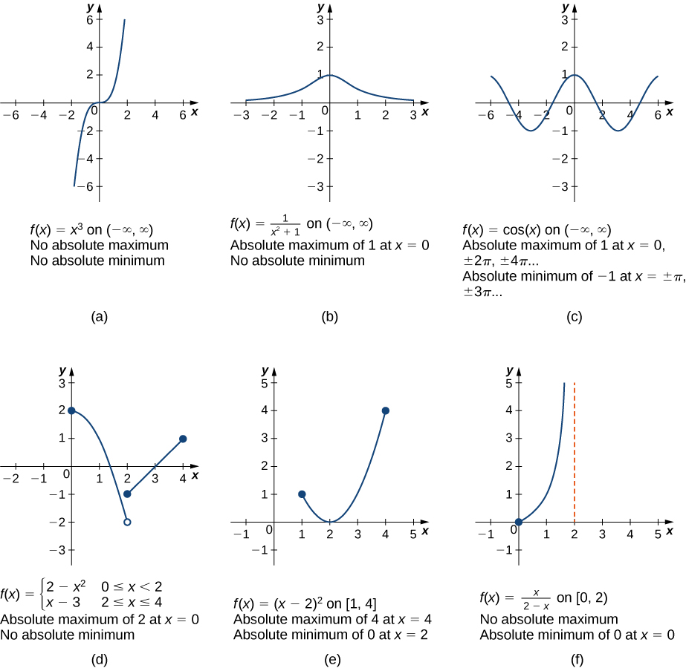

**Extreme Value Theorem**

If $f$ is a continuous function over the closed, bounded interval $[a,b]$, then there is a point in $[a,b]$ at which $f$ has an absolute maximum over $[a,b]$ and there is a point in $[a,b]$ at which $f$ has an absolute minimum over $[a,b]$.

Note: For the extreme value theorem to apply, the function must be continuous over a closed, bounded interval. If the interval $I$ is open or the function has even one point of discontinuity, the function may not have an absolute maximum or absolute minimum over $I$.

Media: Watch this [video](https://youtu.be/votVWz-wKeI) example on finding local and absolute extrema from a graph.

Media: Watch this [video](https://youtu.be/B6XAMbw4CK0) example on drawing a graph with given extrema.

Examples

1. For the following graphs, determine where the local and absolute maxima and minima occur on the graph given.
   1. 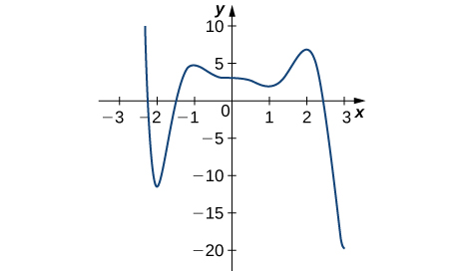



* 1. 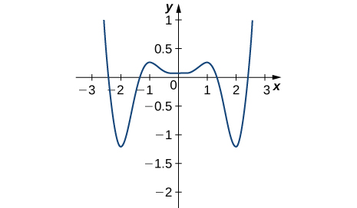



1. For the following problems, draw graphs of $f(x)$, which is continuous, over the interval $[-4,4]$ with the following properties:
   1. Absolute maximum at $x=1$ and absolute minimum at $x=2$.
   2. Absolute maxima at $x=2$ and $x=-3$, local minimum at $x=1$, and absolute minimum at $x=4$.

## Local Extrema and Critical Points

A function $f$ has a **local maximum** at $c$ if there exists an open interval $I$ containing $c$ such that $I$ is contained in the domain of $f$ and $f(c)≥f(x)$ for all $x∈I$.

A function $f$ has a **local minimum** at $c$ if there exists an open interval $I$ containing $c$ such that $I$ is contained in the domain of $f$ and $f(c)≤f(x)$ for all $x∈I$.

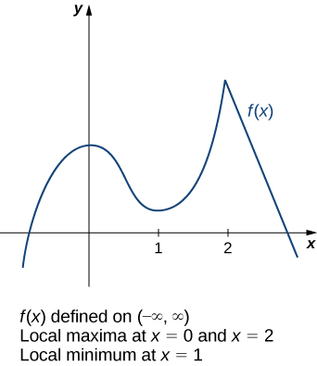Consider the function $f$ shown.

The absolute maximum value of the function occurs at the higher peak, at $x=2$. However, $x=0$ is also a point of interest. We say $f$ has a local maximum at $x=0$. Similarly, the function $f$ does not have an absolute minimum, but it does have a local minimum at $x=1$.

Given the graph of a function $f$, it is sometimes easy to see where the local maximum or local minimum occurs. However, it is not always easy to see, since the interesting features on the graph of a function may not be visible.

Let $c$ be an interior point in the domain of $f$. We say that $c$ is a **critical point** of $f$ if $f^{'}\left(c\right)=0$ or $f^{'}\left(c\right)$ is undefined.

**Fermat’s Theorem**

If $f$ has a local extremum at $c$ and $f$ is differentiable at $c$, then $f^{'}\left(c\right)=0$.

From Fermat’s theorem, we conclude that if $f$ has a local extremum at $c$, then either $f^{'}\left(c\right)=0$ or $f^{'}(c)$ is undefined.

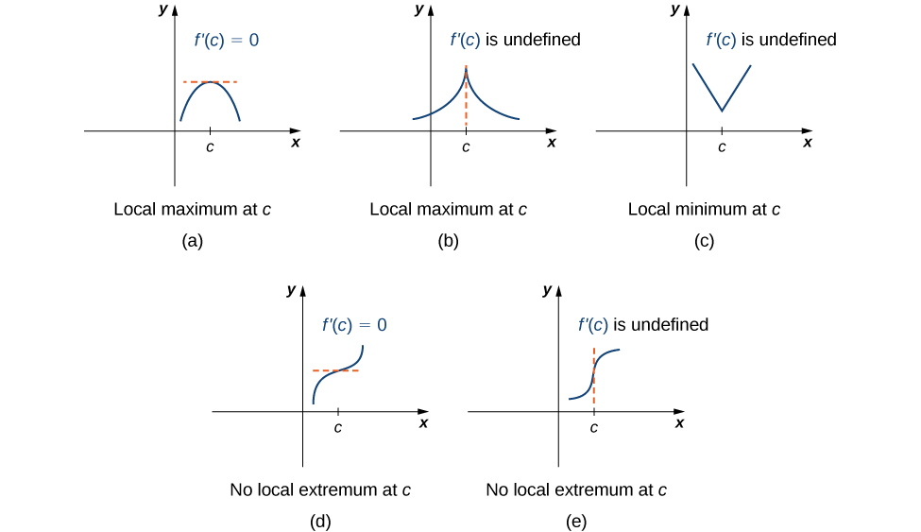

Note this theorem does not claim that a function $f$ must have a local extremum at a critical point. Rather, it states that critical points are candidates for local extrema.

Media: Watch this [video](https://youtu.be/T1iF26hqdpI) example on finding critical numbers of a polynomial function.

Media: Watch this [video](https://youtu.be/dZF4TbYvTM4) example on finding critical numbers of a rational function.

Examples: For each of the following functions, find all critical points. Use a graphing utility to determine whether the function has a local extremum at each of the critical points.

$f\left(x\right)=\frac{1}{3}x^{3}-\frac{5}{2}x^{2}+4x$

$f\left(x\right)={\left(x^{2}-1\right)}^{3}$

$f\left(x\right)=\frac{4x}{1+x^{2}}$

## Locating Absolute Extrema

**Location of Absolute Extrema**

Let $f$ be a continuous function over a closed, bounded interval $I$. The absolute maximum of $f$ over $I$ and the absolute minimum of $f$ over $I$ must occur at endpoints of $I$ or at critical points of $f$ in $I$.

**Locating Absolute Extrema Over a Closed Interval**

Consider a continuous function $f$ defined over the closed interval $[a,b]$.

1. Evaluate $f$ at the endpoints $x=a$ and $x=b$.
2. Find all critical points of $f$ that lie over the interval $(a,b)$ and evaluate $f$ at those critical points.
3. Compare all values found in (1) and (2). From the **Location of Absolute Extrema**, the absolute extrema must occur at endpoints or critical points. Therefore, the largest of these values is the absolute maximum of $f$. The smalles of these values is the absolute minimum of $f$.

Media: Watch this [video](https://youtu.be/ouWgq2MG7Hk) example on absolute extrema on a closed interval.

Media: Watch this [video](https://youtu.be/VU0r1MIdBqI) example on an application of absolute extrema.

Examples

1. For each of the following functions, find the absolute maximum and absolute minimum over the specified interval and state where those values occur.
   1. $f\left(x\right)=-x^{2}+3x-2$ over $[1,3]$
   2. $f\left(x\right)=x^{2}-3x^{\frac{2}{3}}$ over $[0,2]$
   3. $y=x+\sin{x}$ over $[0,2π]$
2. A company that produces cell phones has a cost function of $C=x^{2}-1200x+36,400$, where $C$ is cost in dollars and $x$ is number of cell phones produced (in thousands). How many units of cell phone (in thousands) minimizes this cost function?
3. A ball is thrown into the air and its position is given by $h\left(t\right)=-4.9t^{2}+60t+5$ m. Find the height at which the ball stops ascending. How long after it is thrown does this happen?